How to setup WISP mode for FH1202
Product line: wireless question category: function config
Part 1: Login the homepage of the router
Part 2: Setup connection type and LAN IP
Part 3: Enable WISP mode

The Topology is as below:
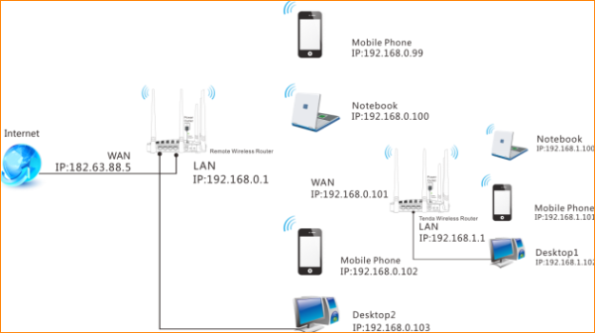

Steps are as following:
1. Login to the management page of the router.

2. Input login username and password as admin, to login, then click Advanced.
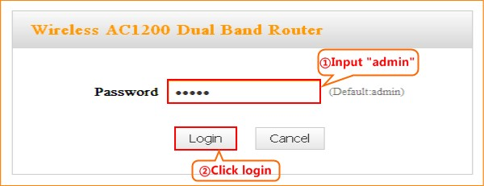
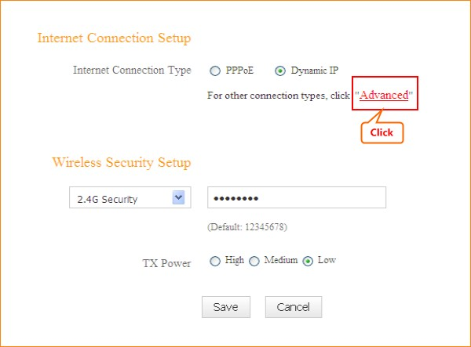

1.Click Network, then click WAN. Choose Dynamic IP, click Save.
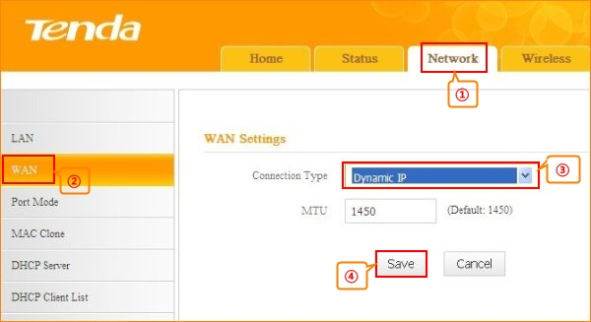
2. Click Network, and then click LAN. Change your router’s LAN IP.(The LAN IP address should be in different network segment. For example, the uplink router has the LAN IP 192.168.0.1, then you can set the secondary router’s LAN IP as 192.168.10.1.)
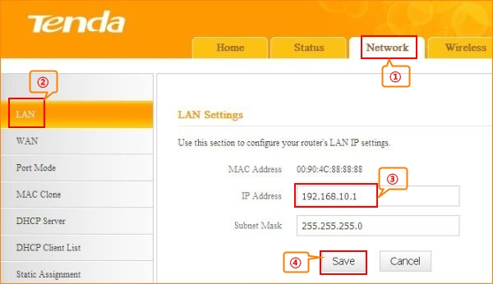
1. Click Wireless and then choose Wireless Extender, choose WISP mode. Click Open Scan.
.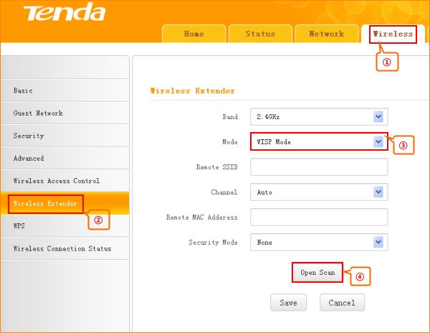
2.Select your uplink router’s SSID, and input your uplink router’s security key. then click Save to save the settings.
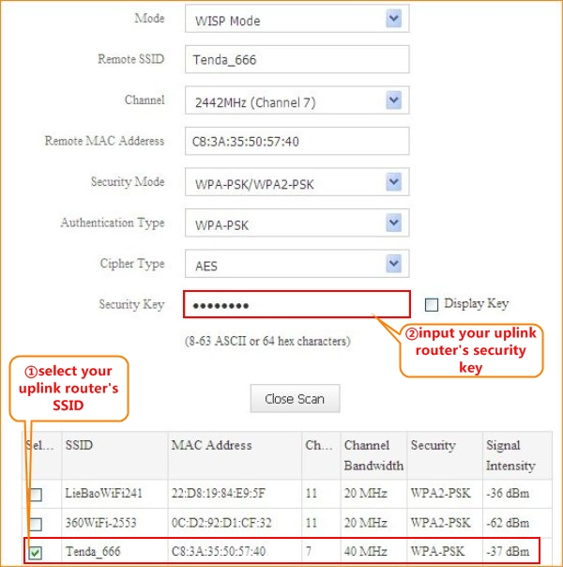
3.After reboot, if the connection status shows connected and get the gateway of uplink router, it means that you can have internet.
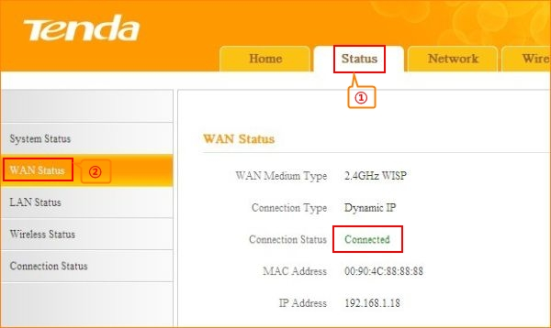
Notice：If you have other PC need to be get connected, please connect it to the one of the LAN port or the wireless signal of the router. There is no need to configure the router again.

